**CPSC 5360_48F_1 - Software Engineering**

**Instructor - Dr. Stefan Andrei**

**Assignment 1**

**Automatic Document Generation**

**Due Date: March, 1st 2015**

**Submitted By:**

**Balram Agrawal (L20365062)**

**Shubhashish Mishra (L20365063)**

**Lucky Singh (L20355322)**

**Submitted On: March, 1st 2015**

**Business Modeling** means to create the use case model, to define the use cases, to create the domain model and to create the glossary.

Electricity Automatic Document Generation System is an automated system that acts as a complex system that creates document like report, statement etc and efficiently generating and delivering these documents to the customers. In addition it helps the customer to obtain those documents by logging into the website and process a payment, if needed.

The use cases for the Electricity Automatic Document Generation System are:

1. Customer interaction to system
   1. Registering new user into the system
   2. Login into the system
2. Checking balance: Allow access to the customer to have access to the statement and balance
3. Payment of bill: Allow payment of the dues if needed.
4. Requesting History
5. Generating History: Allow customer to view past usage of the electricity over time. If a customer wants to compare the current data with the last year data, the Automatic Document Generation should provide this information to the customer and help him/her decide the best thing to do.
6. Information System
7. Benefit Information: Give information about the tips useful for the customers
8. Disaster reporting: To inform the customer about the hurricane/disaster preparedness related to payment of the bill
9. Legislative Activities: To inform the customer about the legislative activities related to their institution.

**Use Case Diagram:**

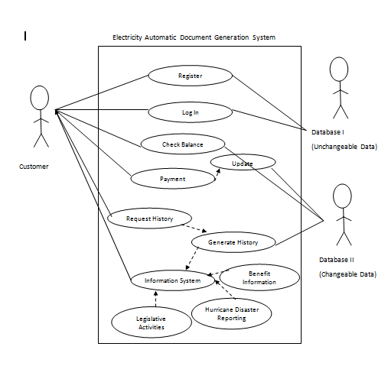

**Domain Model**

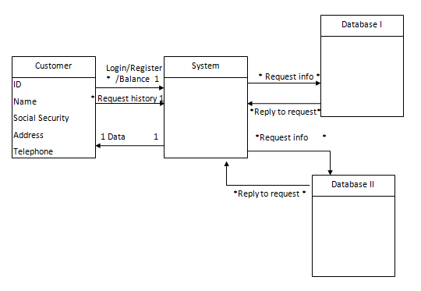

In above domain model the customer interacts with the system and gets right information from the system. The system has interaction with two databases, one with unchangeable data that contains customers name and login credential whiles the other with changeable data that contains data of a time period.

**Sequence Diagram**

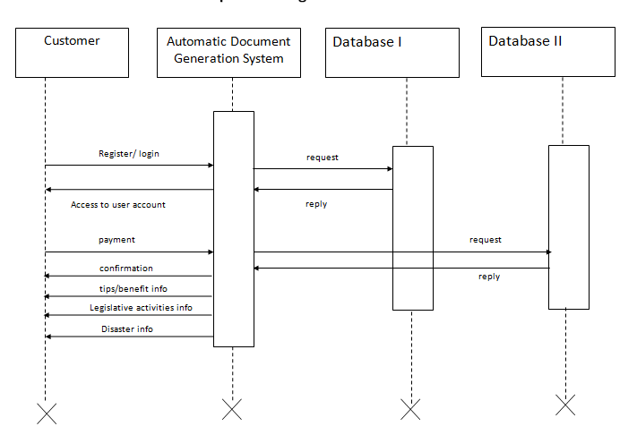

**Class Diagram:**

